Live2Camp.com.au March 2017 Advertising
SUMMARY
Live2Camp.com.au is a dynamic website highlighting bush and beach camping areas in high definition video. The content is unique, authentic and relevant. As a result, the readership of the website is ever-growing and over the last 3 months has quadrupled.

To discuss your advertising needs, please contact Matt Bloomfield at matt@live2camp.com.au
SITE TRAFFIC
These are the traffic statistics for the month of March 2017 as reported by Google Analytics. In addition, Live2Camp has approximately 16,500 Facebook followers and 49,000 views on Youtube. These figures are growing every day.
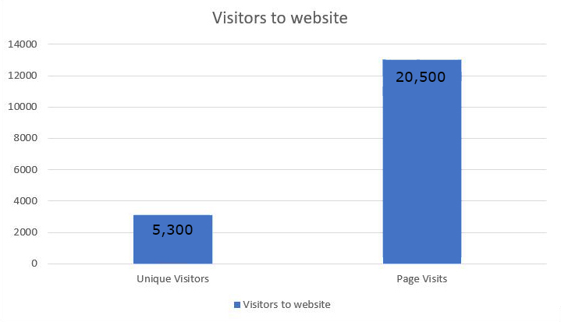

Live2Camp.com.au March 2017 Advertising
We offer three different kinds of ads, banner ads on the header and footer of the website, ads within specific pages of the website and ads in the online magazine. Prices and descriptions are below and some examples have been added on page 3.
Position 1  Banner ad on header | This ad would sit on the header of the website and therefore is seen on every page. This ad rotates with 4 other advertisers. | $35 per month
Position 2  Ad on sidebar of front page of website | This ad sits on the front page of the website. | $50 per month
Position 3  Ad on area-specific page on website ie: Queensland or specific camping area | This ad would be advantageous for advertisers in a specific area of Australia. | $20 per month
Position 4  Full page ad in online magazine | A full page ad inside the monthly online magazine. | $100 per month
Position 5  Half page ad in online magazine | A half page ad inside the monthly magazine. | $50 per month

Live2Camp.com.au March 2017 Advertising
ADVERTISING EXAMPLES
The following are some examples of available advertising.
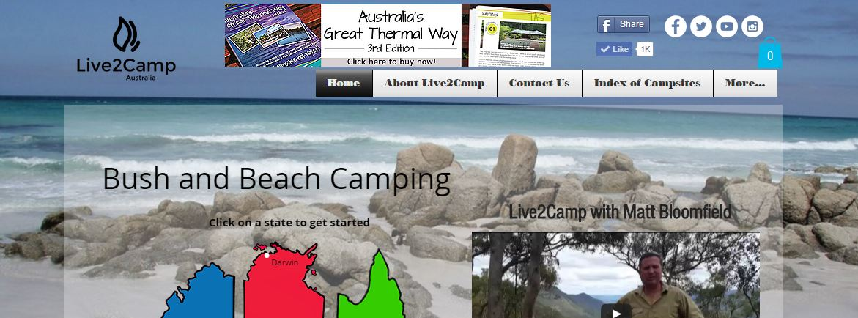
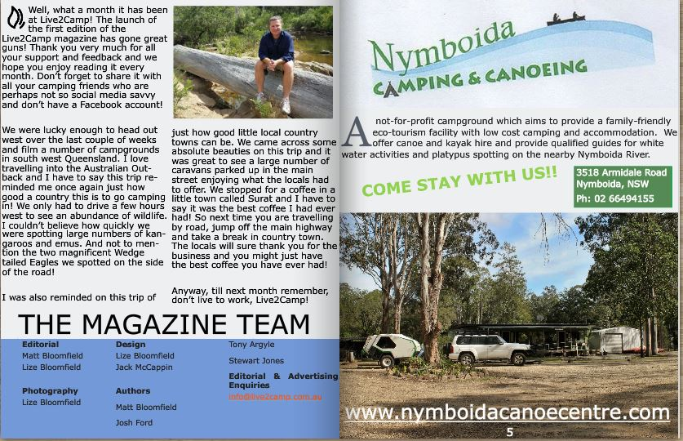

Live2Camp.com.au March 2017 Advertising
GUIDELINES AND POLICIES
Guidelines
The design of your ad is your responsibility however we are more than happy to assist if you need help. Sizes and dimensions are enforced for everyone’s mutual benefit. We do not allow animations on any ads.

Review
We reserve the right to approve all ads and to reject any advertiser for any reason. We are not liable for any claims arising from your ad or any errors in it.

Rates
All rates are subject to change.

Payment
We have payment options including direct debit into Live2Camp account and also via credit card in Paypal.

Additional Information
For additional questions about advertising, please email Matt Bloomfield at matt@live2camp.com.au

